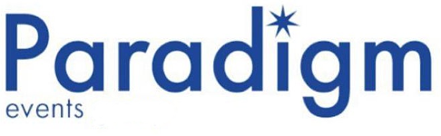

DRY HIRE TERMS & CONDITIONS

Introduction

These terms and conditions (“agreement”) establish the requirements of both the hirer (“person of booking”) and Paradigm Events (“Provider”) during the set period (“hire duration”) and the responsibilities of both parties for the renting of equipment.

Terms

- Agreement of terms and conditions

The hirer agrees to be legally responsible as of the terms and conditions within this agreement.

- Duration of Hire

This agreement becomes binding at the booking of the hire up until final confirmation of equipment return. The agreement may not be terminated at anytime during the hire for any reason. The duration of hire is to be agreed with by both hirer and Paradigm before the hire commences and is not to be altered without prior notice between both parties.

- Responsibilities during the hire period

The hirer is responsible for any damages or loss to the rented equipment during the hire period. By agreeing to this document, the hirer agrees to pay any replacement or repair charges for any damage done to the equipment during the hire period.

The hirer is responsible for notifying Paradigm as of any issues with equipment at first instance when the equipment is collected/received, failure to do so will result in the issues being responsibility of the hirer.

- Ownership of equipment
At all times during the hire, the equipment rented to the hirer remains property of Paradigm and is not to be sold or possessed by anyone other than the stated hirer (“person of booking”).

- Misuse and alterations to rented equipment

The hirer agrees to always use the rented equipment for its intended purpose during the hire period and to follow manufacturer guidance and instructions for use.

Modifications to equipment is not permitted at any time by the hirer and will become liable to extra charge should any modifications or alterations be done to the hired equipment. This includes but is not limited to:

- Removal of any Paradigm asset ID tags
- Removal of any manufacturer produced equipment information labels
- Re painting or graffiti of the equipment
- Unscrewing or disassembly of equipment
- Attaching of any foreign objects

- Equipment Returns

The hirer is responsible for returning all rented equipment on time as per the hire booking confirmation. An overdue return charge (£10 per day) is subject to the hirer if the equipment is not returned during the agreed return period.

Overdue return charges are only charged due to negligence of the hirer and will not be charged if an overdue return is due to a courier (“paradigm arranged”) error which is to be confirmed by Paradigm.

- Fees and final billing

By booking a dry hire, the hirer agrees to pay all charges for the equipment hired on time and for any damages caused to the equipment. Paradigm reserves the right to involve third parties should the hirer not conform to these terms and conditions by not paying on time or at all.

